A Python Synopsis on

**Grocery Bill Management System**

Submitted to Manipal University Jaipur

Towards the partial fulfilment for the Award of the Degree of

**BACHELOR OF TECHNOLOGY**

In Computers Science and Engineering

2023-2027

By

Akshit Gupta  
23FE10CSE00454



Under the guidance of

**Mr. Jay Shankar Sharma**

______________________________   
Signature of Teacher  
 Department of Computer Science and Engineering

School of Computer Science and Engineering

Manipal University Jaipur

Jaipur, Rajasthan

**Grocery Bill Management System**

**Introduction**

The Grocery Bill Management System is a Python-based application designed to simplify and automate the billing process for retail stores. With features like customer information management, categorized product selection, tax computation, and bill generation, the system provides a seamless experience for both store staff and customers. Built using the Tkinter library, this project focuses on delivering an intuitive user interface alongside a robust backend to handle billing logic. By integrating customer data and accurate pricing with a user-friendly interface, this system not only reduces manual errors but also enhances operational efficiency. It is an excellent example of how technology can transform traditional retail operations.

**My Journey and Learnings**

This project has been an incredible journey of discovery and learning. Initially, I started with a basic understanding of Python, and as I delved deeper, I uncovered the potential of libraries like Tkinter. Developing this application taught me how to structure a project efficiently, balancing the backends’ logic with the frontend's aesthetics.

Some key takeaways from this project include:

* **Problem-Solving**
* Learning to break down complex requirements into manageable modules, such as customer data handling, product categorization, and tax computation.
* **UI Development**
  + Understanding how to design user-friendly interfaces using Tkinter frames, buttons, and labels.
* **Logic Implementation**
  + Mastering Python's ability to manage calculations, generate unique bill numbers, and display formatted output.
* **Debugging**
  + Overcoming challenges such as aligning components on the interface and ensuring accurate tax calculations.
  + This project has not only strengthened my programming skills but also taught me the importance of user experience in application design.

**Software Used**

* **Python:** The core programming language for this project.
* **Tkinter:** A Python library used to design the graphical user interface.
* **Text Editor/IDE:** Tools like PyCharm or VS Code were used to write, debug, and execute the code.
* **Operating System:** The system runs on any OS capable of supporting Python (Windows/Linux/Mac).

**Backend and User Interface (UI)**

* **Backend:**The backend is powered by Python functions that handle logic, including:
  + Calculating total costs based on product prices and quantities.
  + Applying tax rates dynamically for different product categories.
  + Generating unique bill numbers using the random library.

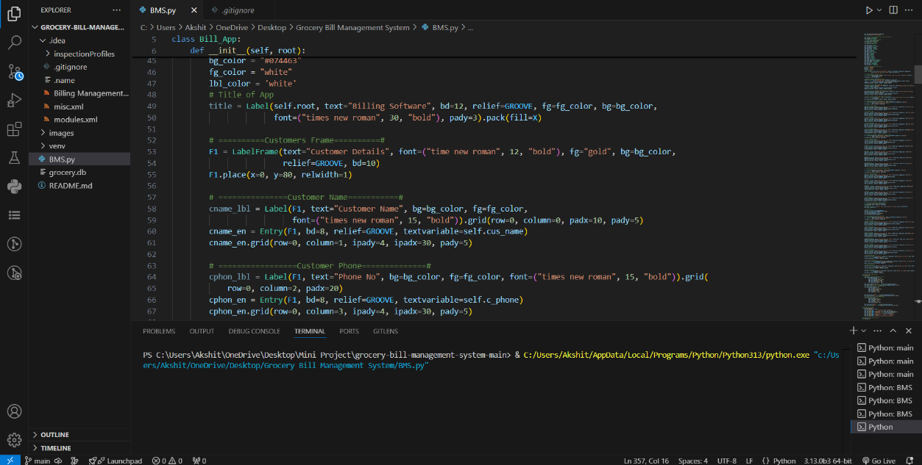

* **Frontend(UI):**  
  The UI, built entirely with Tkinter, ensures a smooth and interactive user experience. Key features of the UI include:
  + Frames and Layouts: For categorizing input sections such as customer details, product selection, and billing area.
  + Buttons and Entry Fields: For data entry, clearing fields, and processing transactions.
  + Scrollable Text Area: To display the generated bill for review or printing.

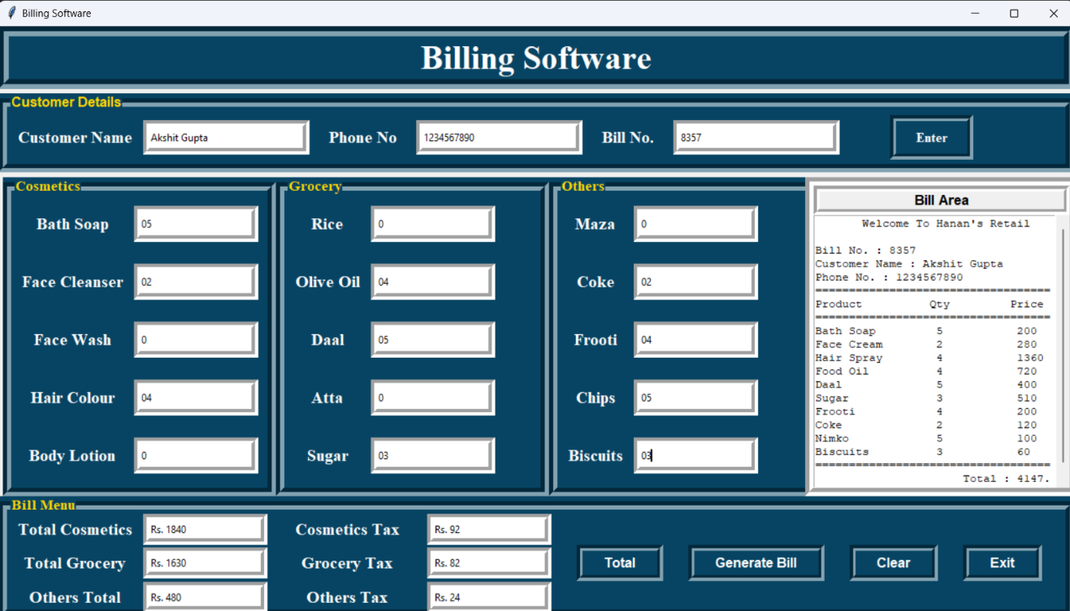

**Key Features**

1. **Customer Information Management**

Captures details like name and phone number and assigns unique bill numbers for transaction tracking.

1. **Product Categorization**

Allows users to select items from categories such as cosmetics, groceries, and other items.

1. **Automatic Tax Calculation**

Computes taxes for each category based on the total price.

1. **Detailed Bill Generation**

Creates a comprehensive bill with product details, tax breakdown, and the final amount due.

1. **User-Friendly Interface**

A clean and responsive UI ensures ease of use for all users.

1. **Portability**

The application is lightweight and can run on any system with Python installed.

**Conclusion**

The Grocery Bill Management System is a complete and efficient solution for streamlining billing in retail environments. It combines robust backend processing with an intuitive interface to ensure accuracy and ease of use. Through this project, I gained valuable insights into software development, problem-solving, and user experience design. This application demonstrates how technology can simplify routine tasks, reduce errors, and improve overall operational efficiency.

**Repositories**

* [**https://github.com/AkshitGupta0225/Python-Lab-Course/tree/main/Mini%20Project**](https://github.com/AkshitGupta0225/Python-Lab-Course/tree/main/Mini%20Project)
* [**https://github.com/AkshitGupta0225/Python-Lab-Course**](https://github.com/AkshitGupta0225/Python-Lab-Course)